System Requirements Statement (SRS) –

Bike_Docter

Doc. Ref. :

Version : 0.4

Status : Drafted

Created by :

Date :

1. Introduction 3

2. Functional Requirements 4

2.1 Customer Module 5

2.2 Service Center Module 8

2.3 admin Module 11

2.4 Use Case Diagram..............................................................................................................................16

THIS DOCUMENT CONTAINS 18 NUMBERED PAGES

# Introduction

This document explains the system requirements and scope for developing Bike Service System.

Bike Service System could divide the three main parts, Customer part, Service center part, Admin part and the acknowledgement part.

This document describes the system requirement of the Account part.

# Functional Requirements

The Account part of Bike Service System has three modules which are divided 13 processes described as below.

|  |  |  |
| --- | --- | --- |
| **No** | **BRS requirement ID** | **Description** |
| **2.1** | **Customer Module** | |
| **2.1.1** | **F1** | **Account Creation Process** |
| **2.1.2** | **F2** | **Login Process** |
| **2.1.3** | **F3** | **Check the service centers** |
| **2.1.4** | **F4** | **Book an appointment** |
| **2.1.5** | **F5** | **Read blogs** |
| **2.1.6** | **F6** | **Road Side Assistance** |
| **2.2** | **Service centre Module** | |
| **2.2.1** | **F11** | **Account Creation Process** |
| **2.2.2** | **F12** | **Login Process** |
| **2.2.3** | **F13** | **Create Slots** |
| **2.2.4** | **F14** | **Update Appointment** |
| **2.2.5** | **F15** | **Billings** |
| **2.2.6** | **F16** | **Payment** |
| **2.3 Admin Module** | | |
| **2.3.1** | **F21** | **Login Process** |
| **2.3.2** | **F22** | **Forgot Password Process** |
| **2.3.3** | **F23** | **Change Password Process** |
| **2.3.4** | **F24** | **Update Account Process** |
| **2.3.5** | **F25** | **Report Generation** |
| **2.3.6** | **F26** | **Account Management** |

## 2.1 Customer Module

* The customer is the user of the portal who uses the system and looks for booking appointments for their bike’s servicing.
* The customer can view the available appointment slots from the service centers on the portal and see the base price for servicing their motorcycle, based on the make and model of the motorcycle.
* The customer gets the information about the bill for the servicing and can pay through the portal and can rate the servicing center based on their experience.
* The Customers can read the blogs available on the portal regarding various automobile-related topics and can get information about Road Side Assistance through the portal.

### 1 Account Creation Process

* The vehicle servicing portal requires an account to be created before using it. Thus the portal has the function to create a new account.
* The portal would ask for information as followed for creating a new account:

1. User id
2. Password
3. Name
4. Contact Number
5. Current address
6. Email id
7. User type
8. Security question

* All the fields are compulsorily demanded.
* User id: The user id should be unique. If the user id entered by the new user for registration matches with any of the previously registered user id, then the user will be prompted to enter another user id and not be registered on the same id.
* Password: The password will have constraints that will make it strong. The password will be masked by dummy characters. The password needs re-entering. The password length should be between 8 to 16 letters and should contain:

1. At least one capital alphabet
2. At least one small alphabet
3. At least one special character
4. At least one numeric figure

* The contact details will be mandatory for creation of the account and the user won’t be allowed to proceed further unless all the details are filled.
* User type: The user will be of three types:
* Customer
* Service Center
* Admin
* The registering entity can however only choose between the customer and the service center. Registering as Admin would not be made available as Admin would be present in the system by default.
* The customer would have to select a security question, eg. The name of their pet, and the answer to it. This will be used to confirm their identity in case of password reset.

### 2.1.2 Login Process

* Once the account is created, the customer can log in using the user id and password they assigned themselves.
* When the credentials are entered, they will be checked in the following ways before granting access:
* The user id and password should be available in the database.
* They should make the correct pair.
* When the entered credentials match the above criteria, the customer would be granted access to their account.
* If in case the customer forgets the password, they can opt to change their password.
* For this, they will have to enter the user id they have and answer the security question they selected while registering.
* When the user id and the security questions answer match, the customer will be allowed to enter and re-enter new password for their account.
* They can log in using the newly created credentials.
* Once logged in, the customer would get some options as mentioned below:
* Check the service centers
* Book appointment
* Read blogs
* Road Side Assistance.

### 2.1.3 Check the service centers:

* The customer will get an option to check the service centers registered to the portal.
* The customer will be able to see their names, addresses and the overall ratings given by the previous users.

### 2.1.4 Book an appointment:

* The customer can book an appointment for the servicing of their motorcycle with the service centre of their choice.
* When they select this option, they will be prompted to select the make and model of their motorcycle from the options displayed.
* When the customer selects the make and model, they will get the estimate for the base servicing of their motorcycle.
* Then they can proceed to select the desired appointment slot for their motorcycle servicing.
* The customer will be displayed a list of service centers as seen previously and their available servicing slots.
* When the customer selects the desired slot from the available ones, the booking will be confirmed.
* On completion of the servicing, the customer can view the bill for their servicing as updated by the servicing center.
* The customer can opt to pay through the portal for the servicing.
* After payment only they will be asked to rate their experience which will prevent fraud and false ratings.

**2.1.5 Road Side Assistance:**

* In case of any malfunction with the motorcycle on the road, the customer can select this option to get Road Side Assistance for their motorcycle.

**2.1.5 Read blogs:**

* The customer can opt to read blogs written about various automobile-related topics.

.

## 2.2 Service Center Module

* **The Service centre is the user of the portal who uses the system and looks for scaling up the business by having service booking appointments from bike owners**
* **The service centre can view the service appointment request and available slots and also they can update their slots for servicing appointments.**
* **The service center can create as well as update the bill for the servicing done to a customer's bike.**
* **The service center can view the payments recieved from customers. The service center can also view the transaction records**.

### 2.2.1 Account Creation Process

* **E-Bike Servicing System requires to create the account before using it. So, E-Bike servicing System should provide the function which makes Service centre creates new account.**
* **When Service centre creates new account, the function demands four information described as below.**

1. Login information

2. Contact Details

3. Security Question Information

4. Payment information.

* The Login information

The Login information consists of some items described as below.

1. UserID

2. Password

3. First Name

4. Last Name

5. E-mail address

6. User Type

7. Security Question

* + All items are compulsory demanded.
  + UserID
* The UserID should be unique. If the UserID correspond with not case-sensitive to other which is previously registered, the UserID should not be registered as an account.
  + Password
* The Password has constrains which makes the Password consists of more than or equal 8 and less than or equal 16 characteristics including characters described as below.

1. Numeric figure (at least one)

2. Capital alphabet (A-Z)(at least one)

3. Small alphabet (a-z)(at least one)

4. Special character (#, $, %, &, etc.) (at least one)

* The contact details will be mandatory for creation of the account and the user won’t be allowed to proceed further unless all the details are filled.
  + User Type

The User Type falls into three categories described as below.

1. Customer

2. Service center

3. Admin

* The User Type defines also three types of user; "Customer", "Service center", and "Administrator user".
* The registering entity can however only choose between the customer and the service center
* In an Account Creation Process, the user can select Service center.
* No one could select The Administrator, because Administrator is implemented to e-Bike Servicing System in advance.

### 2.2.2 Login Process

* E-Bike servicing System always requires service center authentication before using itself except when a new account is successfully created.
* The user authentication demands UserID and Password. The UserID and the Password should be checked in three ways.
  + First, The UserID and the Password should be existed and correct.
* If The UserID and the Password are not equal to what the user has registered, the user authentication cannot be provided.
  + Second, the User Type linked to the UserID should be "user".
* When the User Type is "Service Center", user can be placed on “Service Center Home”.
  + Finally, UserID should be available.
* The Administrator can decide whether the UserID is available or suspended – Refer to the SRS of the Admin part.

**2.2.3 Create slots:**

* **The service center will get an option to see the appointments book for their service centers.**
* **The service center will be able to create the appointments for servicing.**

**2.2.4 Update appointment:**

* **The service center will be able to see the appointments book for their service center.**
* **The service center can update the appointments schedule according to the requirement and condition.**

**2.2.5 Billings:**

* **The service center will be able to create bills for a bike serviced at their center.**
* **The service center will also be able to update the bills accordingly**

**2.2.6 Payments:**

* **The service centers can have the liverage to see the payment recieved from customers.**
* **Service centers will also be having the authority to see the transaction records.**

#### Admin Module

**•** Administratorshould be responsible for following activities**,**

### Login Process

* Bike Service System always compels user authentication before using itself except when a new account is successfully created.
* The user authentication demands UserID and Password. The UserID and the Password should be checked in three ways.
  + First, The UserID and the Password should be existed and correct.
* If The UserID and the Password are not equal to what the admin has registered, the Admin authentication cannot be provided.
  + Second, the User Type linked to the UserID should be "Admin".
* When the User Type is "Admin", user can be placed on “Admin Home”.
  + Finally, UserID should be available.
* The Administrator can decide whether the UserID is available or suspended – Refer to t
* .0he SRS of the Admin part.
* If user is rejected, user authentication is not provided for system user.
* The Admin account should alive for so long as the duration decided by Admin.
* Only when the three checks are successfully completed, Admin can be placed on respected page.
* Here are some key features that the admin page should include:

1. Dashboard:

The admin page should have a dashboard that provides an overview of important system metrics, such as the total number of registered customers, active service centers, pending appointments, and recent transactions. The dashboard can also display graphical representations of data for quick insights.

1. User Management:

The admin page should allow administrators to manage user accounts, including creating new accounts, modifying user details, and deactivating or deleting accounts when necessary. Administrators should have the ability to assign roles and permissions to control access to different system functionalities.

1. Service Center Management:

The admin page should provide functionality to manage service centers. Administrators should be able to view and access information about all registered service centers, including their contact details, location, services offered, and ratings. The admin should have the ability to add new service centers, edit existing center details, and deactivate or remove service centers if needed.

1. Appointment Management:

The admin page should allow administrators to view and manage appointments made by customers. Administrators should be able to see the appointment details, such as the customer name, service center, appointment time, and service requested. They should have the ability to reschedule or cancel appointments and assign them to different service centers or mechanics if required.

1. Transaction Monitoring:

The admin page should provide a transaction monitoring feature that allows administrators to view and track all financial transactions related to the bike service system. This includes payments made by customers, service charges, refunds, and any other financial transactions. The admin should have access to detailed transaction information, such as transaction IDs, dates, amounts, and payment status.

1. Reports and Analytics:

The admin page should include reporting and analytics capabilities. Administrators should be able to generate various reports, such as service performance reports, revenue reports, customer feedback reports, and service center utilization reports. These reports provide valuable insights into the system's performance and help in making informed decisions and identifying areas for improvement.

1. System Configuration:

The admin page should provide options for system configuration. Administrators should be able to customize settings, such as service categories, pricing rules, business hours, and notification preferences. They should also have the ability to manage tax rates, discounts, and promotions.

1. Customer Support:

The admin page should include features to handle customer support requests. Administrators should be able to receive and respond to customer inquiries, complaints, and feedback. This may include a ticketing system or a communication platform to facilitate efficient communication with customers.

### Forgot Password Process

* When Admin lost their Password, the recovery method should be provided by e-Farming system.

The recovery method is described as below.

* + First, Admin enters their UserID for e-Farming System.
  + He will enter the E-mail id since when the Account was created.
  + Only when the E-mail Id is correct, Admin get the new password by E-mail which also has been registered since when the Account was created.
  + The new password is automatically generated by e-Farming System.
* Of course, the new password should consist of more than or equal 8 and less than or equal 16 characteristics including at least a numeric figure, a capital alphabet, a small alphabet, and a special character.
* As a consequence, The Admin could get the Admin authentication using the new password.
  + Then, the Admin had better change the new password manually.

### Change Password Process

* When Admin wants to change his Password, the measure should be provided by e-Farming System.
* Therefore, E-Farming System should provide the function which is available after getting the Admin authentication.
* The function demands the current password and the new password.
  + Of course, the new password should consist of more than or equal 8 and less than or equal 16 characteristics including at least a numeric figure, a capital alphabet, a small alphabet, and a special character.
  + The current password and the new password are masked by using dummy characters.
  + The new password is demanded to enter twice to avoid a typing error.
* Only when the current password is correct, Admin could change his Password.
* When the current password is changed into new password, E-Farming System compels user authentication again.

### Update Account Process

* E-Farming System should provide the function which makes the account updated for Admin.
* The information Admin could update is described below.

1. Login information
2. User information
3. Security Question Information

* The Login information

The updatable items as described below.

1. First Name
2. Last Name
3. E-mail address
   * All items are compulsory demanded, but updating is optional.

* The User information

The updatable items as described below.

1. User Name
2. User Phone No
3. E-mail address
4. Permanent address
   * All items are compulsory demanded, but updating is optional.

* The Security Question information

The updatable items as described below.

1. Selected Question
2. Answer
   * All items are compulsory demanded, but updating is optional.

#### Record Generation

• Admin should able to see all the records from any users.

• Daily report of enrolment to admin.

• Monthly report of enrolment as per the states to admin.

#### Accounts Management

• Admin should able to manage all the accounts with following activities,

1. Enable accounts

2. Disable accounts

#### 2.5 Use Case Diagram

**Admin:**

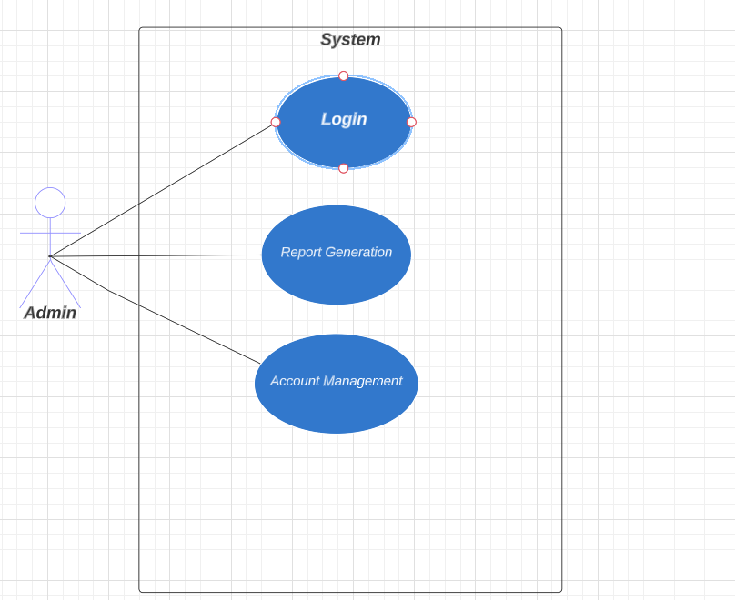

*Fig. Use case diagram for admin*

1. In Admin use case diagram Admin is the Actor.
2. Admin can handle following use cases:
3. Login
4. Report Generation
5. Controls account

**Customer:**

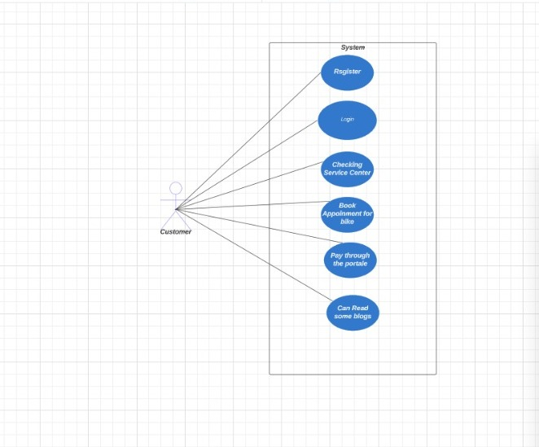

*Fig. Use case diagram for Customer*

1. In Customer use case diagram Customer is the Actor.
2. Customer can handle following use cases:
3. Register
4. Login
5. Checking Service Center
6. Book Appointment for bike
7. Pay through the portal
8. Read some blogs on portal
9. Browse Product Price

**Service Centre:**

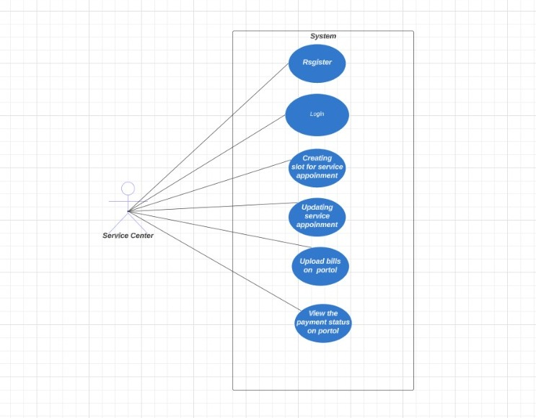

*Fig. Use case diagram for Service Centre*

1. In Service Centre use case diagram Service Centre is the Actor**.**
2. Service Centre can handle following use cases:
3. Register
4. Login
5. Creating slot for appointment
6. Updating service appointment
7. Upload bills on portal
8. View the Payment status on portal